**Summary**

1. Developer Hours:

**Frontend Dev: 770 hrs (excluding map)**

**Backend Dev: 505 hrs (excluding map)**

1. QA Hours: **250 hrs**
2. PM Hours: **100 hrs**

**Start date: Jan 14, 2022**

**Deadline: April 5, 2022**

**Detailed Breakdown of Development Hours**

1. **Frontend Estimation: - 156hrs + 50hrs = 206hrs (For highlighted pages only)**
2. **Style Guide - 46hrs**
   * 1. Typography/ Branding and colors/ Icons setup - **(6hrs)**
     2. Utility Classes - **(6hrs)**
     3. Reusable Components - **(34hrs)**
        1. Buttons
        2. Links
        3. Forms
        4. Navigation
        5. Mega Menu
        6. Header
        7. Footer
        8. Offcanvas
        9. Filter
   * **Modules - 78hrs**
     1. Above the fold - 6 **(16hrs)**
     2. Cards - 10 **(12hrs)**
     3. Slider- 2 **(8hrs)**
     4. Sections - 14 **(42hrs)**
   * **Layout - 32hrs**
     1. **Homepage**
     2. **Search result page**
     3. **Contact**
     4. **About**
        1. **Team || Team bio page**
        2. **Board**
        3. **Funders and partners / Request form**
        4. **Annual Report & Financials**
     5. **Case for food**
     6. **What we can do**
3. **Become a service member**
4. **What you’ll do**
5. **Where you’ll work**
6. **Career options after service**
7. **Bring food corp to your district**
8. **Change the system**
9. **Policy Action Center**
10. **Support our work**
    * 1. **Donate**
      2. **The skillet**
         1. **The skillet news**
         2. **The skillet stories**
         3. **The skillet press**
         4. **Lesson plans**
         5. **Program guide**
         6. **Article template**
         7. **The skillet**
      3. **Equity and Inclusion**
      4. **Career**
      5. **Partner with us**

**Responsive and Breakpoints**

**Animation + Image Mask Research : 50hrs**

1. **Backend Estimation 115 hrs + ( 25hrs if subpages )**

**Global Components: 15 hrs**

1. **Header - 8hrs**
2. **Footer - 5 hrs**
3. **Setup - 2 hrs**

**Pages: 100 hrs**

* **Homepage - 20 hrs**
* **Search result page - 15 hrs**
* **Contact - 8 hrs**
* **About - 8 hrs**
  1. **Team || Team bio page - 11 hrs**
  2. **Board - 6 hrs**
  3. **Funders and partners / Request form - 22 Hrs**
  4. **Annual Report & Financials - 10 Hrs**

**Batch 2**

**Detailed Breakdown of Development Hours**

1. **Frontend Estimation: - 176hrs + 32hrs = 208hrs** 
   * **Modules - 144hrs**
     1. Above the fold - 3 **(12hrs)**
     2. Slider- 3 **(12hrs)**
     3. Modules - 23 **(90hrs)**
     4. Re-use Modules - 16 **(20hrs)**
     5. Form Modules (Donate Form) - 1 **(10hrs)**
   * **Layout - 32hrs**
     1. **Donate**
     2. **What You Can Do**
     3. **Become a Service Member**
     4. **Bring FoodCorps to Your District**
     5. **Support Our Work**
     6. **Career**
     7. **Search**
     8. **Partner With Us**

**Responsive and Breakpoints + Animation : 32hrs**

**Backend Estimation 108 hrs + ( 25hrs if subpages )**

**Pages: 108 hrs**

* **Donate**
* **What You Can Do - 6 hrs**
* **Become a Service Member - 40 hrs**
* **Bring FoodCorps to Your District - 22 hrs**
* **Support Our Work - 15 hrs**
* **Career - 20 hrs**
* **Search**
* **Partner With Us - 5 hrs**

**Batch 3**

**Detailed Breakdown of Development Hours**

**Frontend Estimation: - 126hrs + 20hrs = 146hrs**

* + **Modules - 94hrs**
    1. Above the fold - 1 **(4hrs)**
    2. Slider- 1 **(4hrs)**
    3. Modules - 14 **(56hrs)**
    4. Re-use Modules -18 **(24hrs)**
    5. Shifting Module - 1 **(6hrs)**
  + **Layout - 32hrs** 
    1. **What You’ll Do (**5-reuse) (1-new)
    2. **Where You'll Serve (**1-reuse) (3-new)
       1. **Where You'll Serve Detail Page (**8hrs**)**
    3. **After Service (**2-reuse) (3-new)
    4. **Change the System (**4-reuse) (1-new)
    5. **Policy Action Center (**2-reuse) (1-new) (1-tab layouting)
    6. **Equity Inclusion (**4-reuse) (2-new) (1-shifting module)

**Responsive and Breakpoints + Animation : 20hrs**

**Backend Estimation 91 hrs + ( 15hrs if subpages )**

**Pages: 91hrs**

* **Policy Action Center - 16 hrs**
* **Change the System - 10 hrs**
* **What You’ll Do - 10 hrs**
* **Where We Work - 14 hrs ( excluding map, map estimation after map research )**
* **Site Detail Pages - 10 hrs**
* **Action for Equity Inclusion - 16 hrs**
* **After Service - 15 hrs**

**Ps:** Map not included

**Batch 4**

**Detailed Breakdown of Development Hours**

**Frontend Estimation: - 190hrs + 20hrs = 210hrs**

* + **Modules - 150hrs**
    1. Above the fold (4-hero variation) - 2 **(12hrs)**
    2. Modules - 27 **(108hrs)**
    3. Re-use Modules -24 **(38hrs)**
  + **Layout - 32hrs** 
    1. **What We Do (**5-reuse) (2-new)(1-FPO)
    2. **The Case for Food (**Design to be provided)
    3. **The Skillet (**7-reuse) (7-new) (1-tab layouting)
    4. **Impact (**4-reuse) (3-new)
    5. **Program Guide (**3-reuse) (2-new)
    6. **Article Template (**1-reuse) (8-new) (4-hero variation)
    7. **Lesson Plan (**4-reuse) (6-new)

**Responsive and Breakpoints + Animation : 20hrs**

**Backend Estimation 100 hrs + ( 25hrs if subpages )**

**Pages: hrs**

* **What We Do - 10 hrs**
* **The Case for Food - Cannot found design**
* **The Skillet - 40 hrs**
* **Impact - 11 hrs**
* **Program Guide - 14 hrs**
* **Article Template - 10 hrs**
* **Lesson Plans - 15 hrs**

**Ps:** The Case for Food Design to be provided

**Batch 4 Questions:**

1. **Does these icons stack on mobile devices ?**

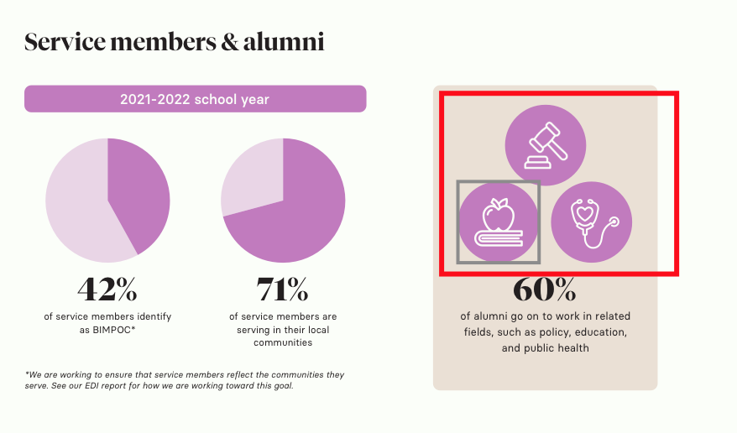

1. **Do these Resources have a detailed page?**

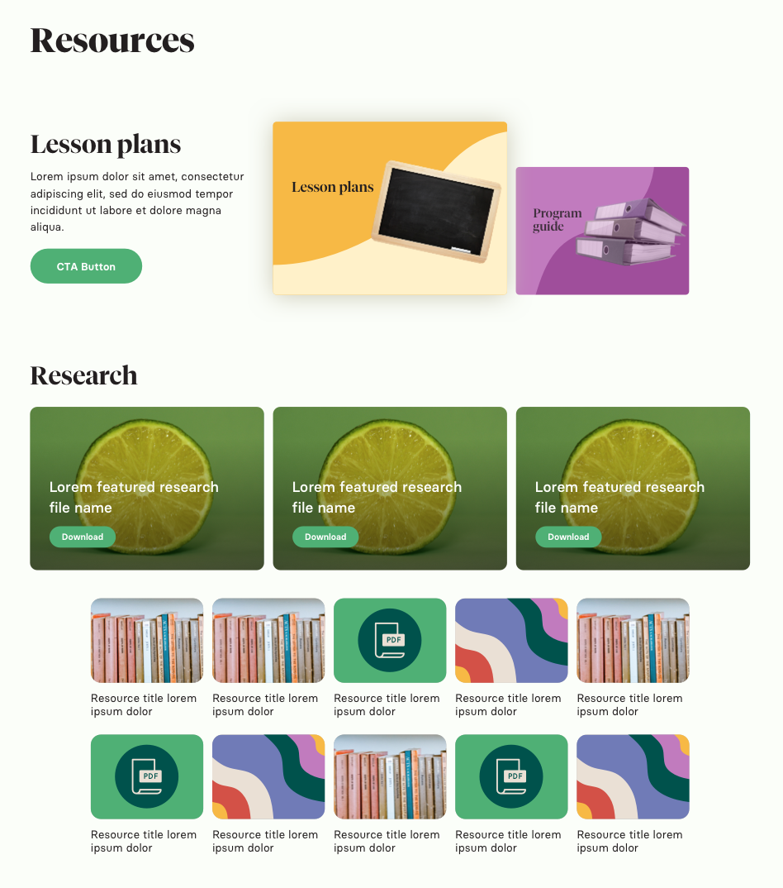

1. **Does this lesson plan have a detailed page? What file extension are users going to upload(eg: pdf)**

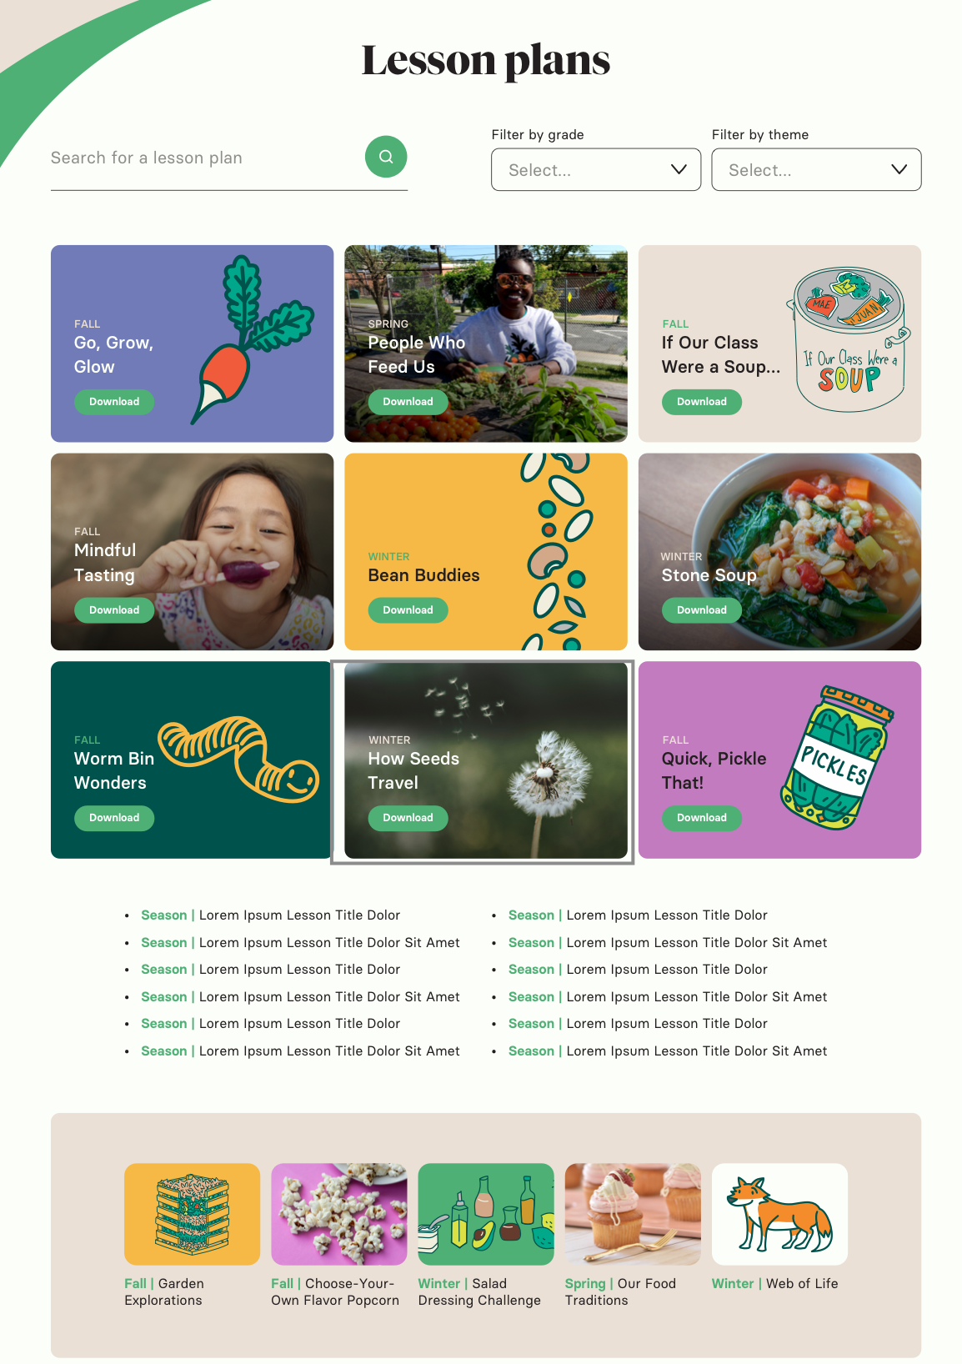

1. **Does this video play in a popup model? What happens when we click on to ‘see the full list of videos’, does this link open the provided doc linked?  
   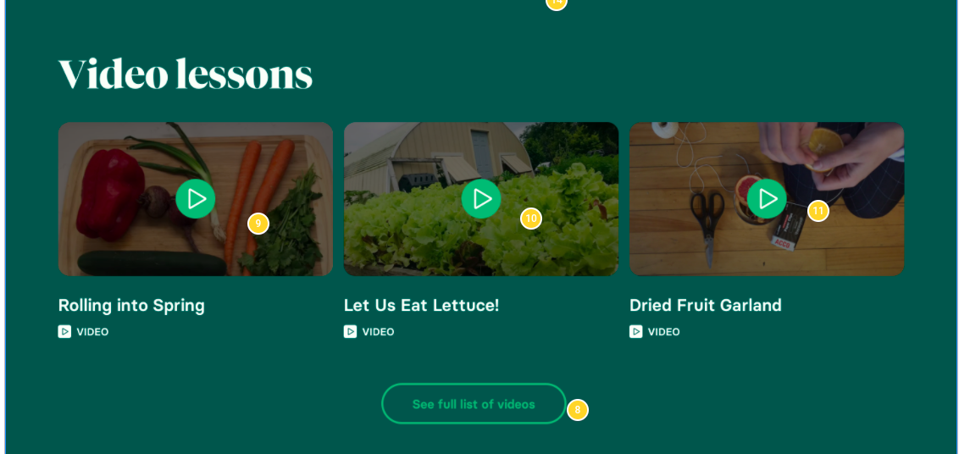**
2. **Where does the season link to? Or is it only for listing?**

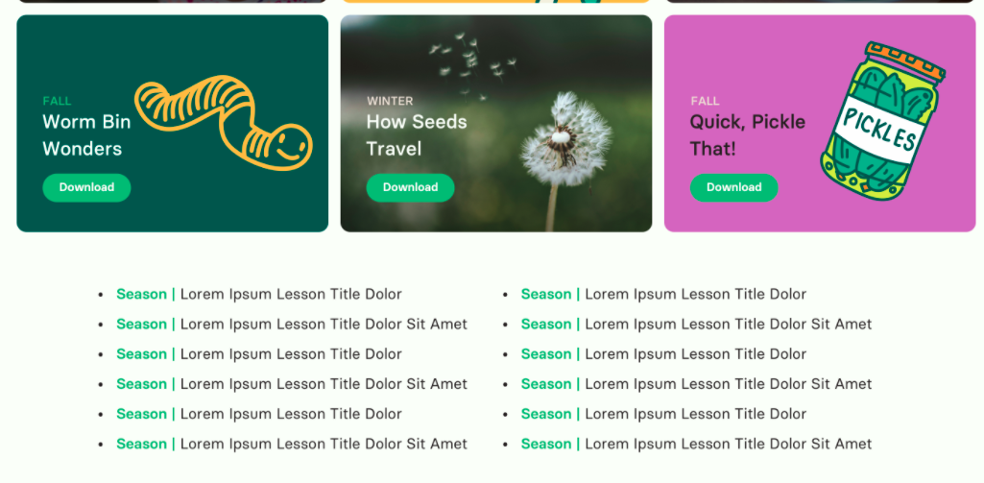

1. **Can you please elaborate more on this section?   
   